**QUORUM: (President or President-Elect, 3 Committee Members (including 1 elected Executive Committee Member)**

|  |  |  |  |  |  |
| --- | --- | --- | --- | --- | --- |
| Attended | Name | Position | Attended | Name | Position |
| ☒ | Carolyn Oakes | President | ☐ | Rich Warner | Government Affairs |
| ☐ | Jessica Vargas | President-Elect | ☐ | Phillip Combest | Awards & Honors |
| ☐ | Royce Hossler | Secretary | ☐ | Danni Acevedo | Communications |
| ☒ | Art Pedroza | Treasurer | ☐ | Danny Kim | Student Section |
| ☐ | Teddi Penewell | Advisory Board | ☐ | Eric Brown | Mentorship |
| ☒ | Bob Howarth | Advisory Board | ☒ | Bhavika Lodhia | Membership |
| ☐ | Georgette Quinn | Advisory Board | ☒ | Brian Nguyen | Member at Large |
| ☒ | Haley Binder | Job Chair |  |  |  |
| ☐ | ~~Rollin Gordon~~ | Programs |  |  |  |
|  |  |  |  |  |  |

**QUORUM / CALL TO ORDER**

* A quorum being present, the meeting is called to order at 12:04by President, Carolyn Oakes

**APPROVAL OF PREVIOUS MEETING MINUTES**

* Approved

**OLD BUSINESS: (PREVIOUS ACTION ITEMS)**

**_______________________________________________________________________________________________**

**NEW BUSINESS:**

1. **PRESIDENT REPORT (Carolyn reporting)**

* Brian will hold the nomination chair for the 2025-2026 term. Brian will be assistin Jess and Carolyn in getting board positions filled and will be reaching out
* Announcement – Brian is the ARP for Nominationa and Awards – email will be comign out soon about the upcoming SPY awards

1. **PRESIDENT-ELECT REPORT (Jessica Reporting)**

* NA

1. **TREASURER REPORT (Art reporting)**

* Reviewed below content with the board

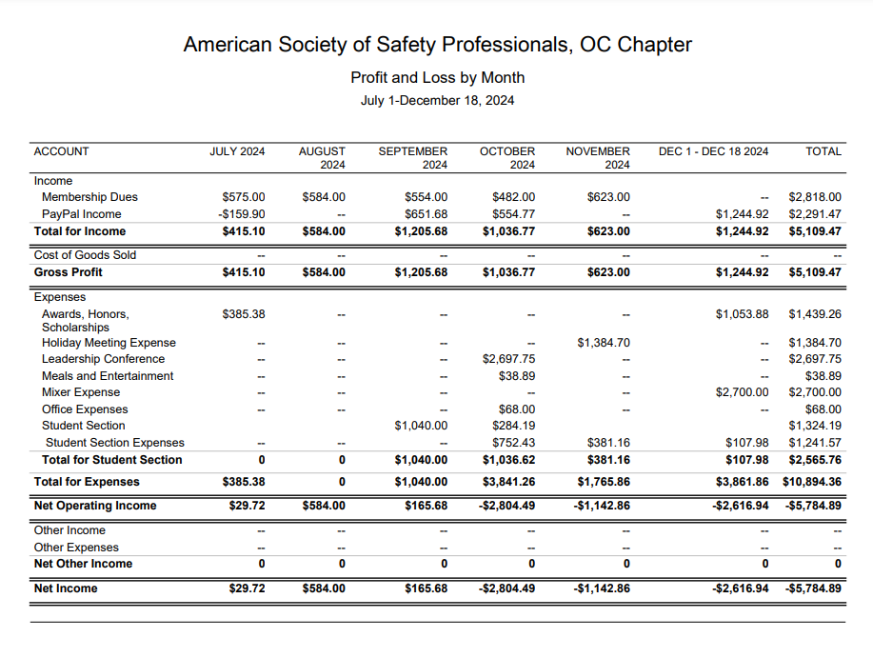

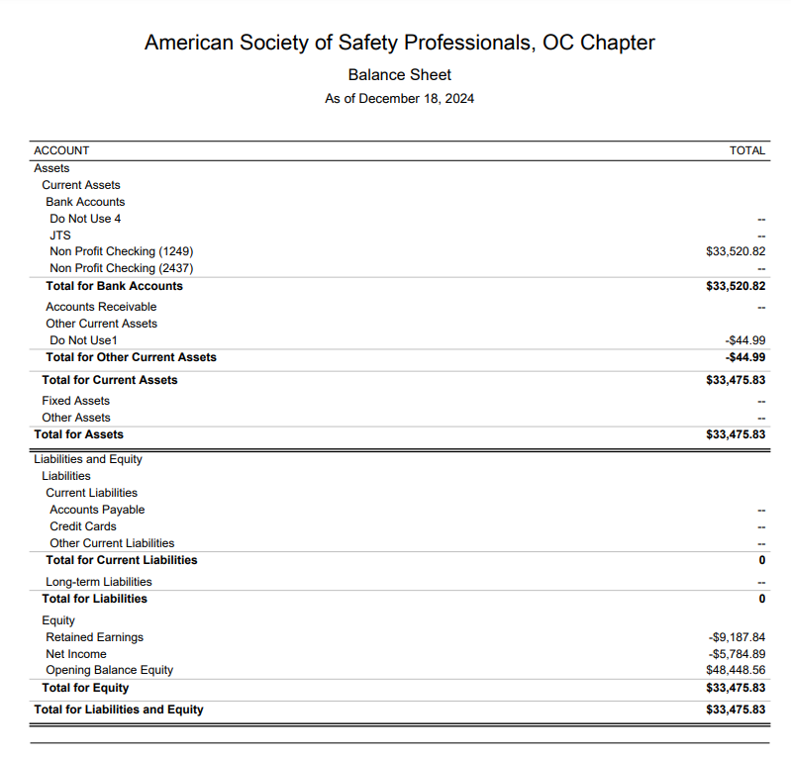

* Additional revenue from JTS
  + Audiovisual was a major cost savings – had the presenters provide their own
  + Additional headcount
    - Last year we had 209 and this year we had 239

1. **STUDENT SECTION (Danny reporting)**

* NA

1. **PROGRAMS (Carolyn reporting)**

* Upcoming
  + 10/26 - Beach cleanup 4PM Huntington Beach
  + 11/14 - Joint event with the LA chapter on November 14th. The presentation will be Heat Illness given by Cal OSHA held at the American Red Cross in Santa Ana
    - Who can help coordinate?
    - Phil to pick up food
    - Tracy to help coordinate
  + **12/17** Holiday Party - Third Tuesday of December held at Lucky Strikes (same as last year)
  + February - Plant tour - We have someone offering their wastewater facility in San Bernardino County.
    - Send James a few date proposals – waiting for his response
  + March volunteering event with the OC Food Bank – Saturday Marth 15th
  + ??? - Fall protection meeting at 3M facility in Tustin
    - **Action** – Carolyn to follow back up with the 3M contact
  + May: Joint Meeting with RIMS. RIMS is planning
    - Tracy and Phil have engaged – still waiting for more information

1. **ADVISORY BOARD REPORT (Bob/Teddi/GQ Reporting)**

* Feedback from board provided for the meeting on December 5th – identifying potential tallent, mentorship and what type of support is needed to get people engaged
  + Felt that there wasn’t a lot of new information for our chapter and that we’re doing a gret job of succession planning
  + Gameplan from ASSP as a way to help the chapter: [december---ag-breakout-room-summaries.pdf](https://www.assp.org/docs/default-source/default-document-library/december---ag-breakout-room-summaries.pdf?sfvrsn=c9927a46_0) and [24-25_advisory_group_workplan.pdf](https://www.assp.org/docs/default-source/default-document-library/24-25_advisory_group_workplan.pdf?sfvrsn=ecb07846_0)
* Next meeting on February 27nd
* How can we better connect with our student members? Do students know they have a year of free membership after they graduate?
  + Bhavika has created a letter for the graduating class which highlights these benefits
    - **Action** – everyone to review the letter
    - **Action** – make the update about the free year of membership with the local ASSP chapter
    - This letter was sent out last year
  + Could someone from the board attend the last student meeting and help them all register for the local chapter?
    - **Action** – Carolyn to connect with Danny about how we could better communicate with the student chapter before graduation?

1. **GOVERNMENTAL AFFAIRS (Rich Reporting)**

* NA

1. **COMMUNICATIONS / WEB (Danni Reporting)**

* NA

1. **SOCIAL MEDIA (Haley Reporting)**

* Four new posts over the last month – lots of engagement
* **Action** – Haley to post the video Brian created on LinkedIn

1. **HONORS & AWARDS REPORT (Phil reporting)**

* NA

1. **MENTORSHIP PROGRAM (Eric/Danny reporting)**

* Had the first meeting with mentors and mentees last week
* **Action** – Carolyn to get the final total of mentors and mentees
* **Action** - Danny and Eric to provide details about how they expanded the mentors (LB, LA and OC), and mentees (more schools)
* **Action** – Danny and Eric to provide details about expections and what will be accomplished during the program

**11. JOBS (Haley Reporting)**

* No new jobs posted – one message on LinkedIn about a potential job

**12. MEMBERSHIP (Bhavika reporting)**

* No new messages from the month of December
* **Action** – Carolyn and Bhavika to connect about pulling the membership report

**_________________________________________________________________**

**ADJOURNMENT**

* **Meeting adjourned** at **12:48** pm

**NEXT MEETING**

* **Third Wednesday of each month**
* **January 15, 2024 (12:00 pm)**
  + Join Zoom Meeting:
    - Meeting ID: 869 4414 9119
    - Passcode: OCASSP
    - Link: https://us06web.zoom.us/j/86944149119?pwd=akdjS1U3MmR6NWZLcEYyUkFROWcwdz09

**_______________________________________________________________________________________________**

**RECAP OF NEW AND CARRY OVER ACTION ITEMS FROM THIS MEETING**

* **Action** – Carolyn to follow back up with the 3M contact
* **Action** – everyone to review the letter
* **Action** – Bhavika make the update about the free year of membership with the local ASSP chapter
* **Action** – Carolyn to connect with Danny about how we could better communicate with the student chapter before graduation?
* **Action** – Haley to post the video Brian created on LinkedIn
* **Action** – Carolyn to get the final total of mentors and mentees
* **Action** - Danny and Eric to provide details about how they expanded the mentors (LB, LA and OC), and mentees (more schools)
* **Action** – Danny and Eric to provide details about expections and what will be accomplished during the program
* **Action** – Carolyn and Bhavika to connect about pulling the membership report

**____________________________________________________________________________________**