QUORUM: (President or President-Elect, 3 Committee Members (including 1 elected Executive Committee Member)
Attended | Name | Position | Attended | Name | Position
☒ | Carolyn Oakes | President | ☐ | Rich Warner | Government Affairs
☐ | Jessica Vargas | President-Elect | ☐ | Phillip Combest | Awards & Honors
☐ | Royce Hossler | Secretary | ☐ | Danni Acevedo | Communications
☒ | Art Pedroza | Treasurer | ☐ | Danny Kim | Student Section
☐ | Teddi Penewell | Advisory Board | ☐ | Eric Brown | Mentorship
☒ | Bob Howarth | Advisory Board | ☒ | Bhavika Lodhia | Membership
☐ | Georgette Quinn | Advisory Board | ☒ | Brian Nguyen | Member at Large
☒ | Haley Binder | Job Chair
☐ | Rollin Gordon | Programs

QUORUM / CALL TO ORDER
- A quorum being present, the meeting is called to order at 12:04 by President, Carolyn Oakes

APPROVAL OF PREVIOUS MEETING MINUTES
- Approved

OLD BUSINESS: (PREVIOUS ACTION ITEMS)
_______________________________________________________________________________________________

NEW BUSINESS:
- PRESIDENT REPORT (Carolyn reporting)
- Brian will hold the nomination chair for the 2025-2026 term. Brian will be assistin Jess and Carolyn in getting board positions filled and will be reaching out
- Announcement – Brian is the ARP for Nominationa and Awards – email will be comign out soon about the upcoming SPY awards

- PRESIDENT-ELECT REPORT (Jessica Reporting)
- NA

- TREASURER REPORT (Art reporting)
- Reviewed below content with the board
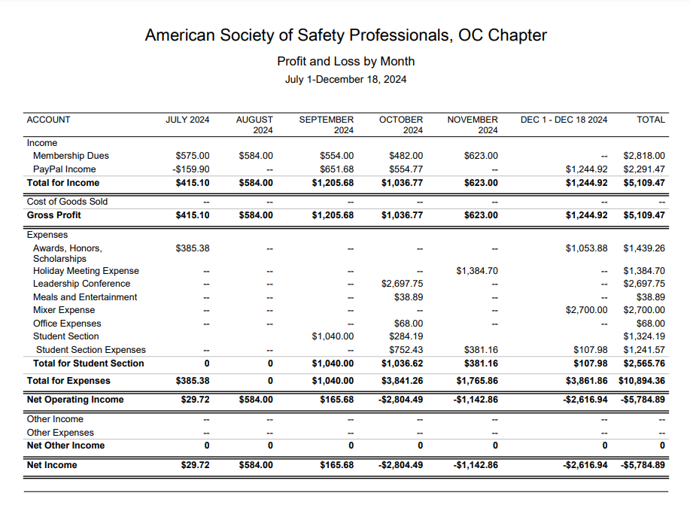
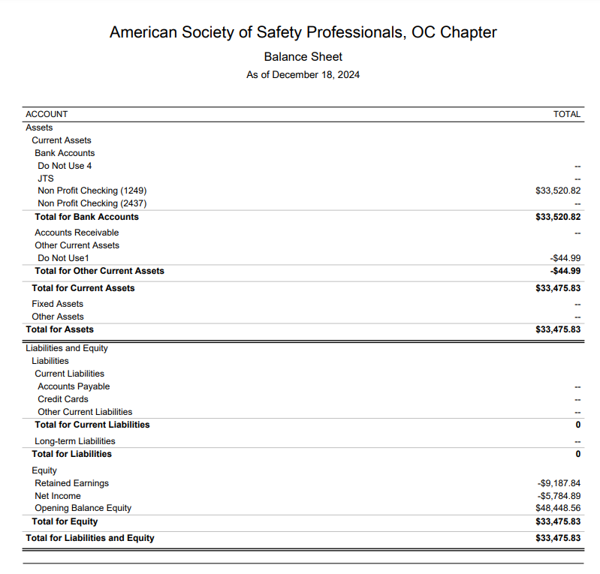
- Additional revenue from JTS
  - Audiovisual was a major cost savings – had the presenters provide their own
  - Additional headcount
    - Last year we had 209 and this year we had 239

- STUDENT SECTION (Danny reporting)
- NA

- PROGRAMS (Carolyn reporting)
- Upcoming
  - 10/26 - Beach cleanup 4PM Huntington Beach
  - 11/14 - Joint event with the LA chapter on November 14th. The presentation will be Heat Illness given by Cal OSHA held at the American Red Cross in Santa Ana
    - Who can help coordinate?
    - Phil to pick up food
    - Tracy to help coordinate
  - 12/17 Holiday Party - Third Tuesday of December held at Lucky Strikes (same as last year)
  - February - Plant tour - We have someone offering their wastewater facility in San Bernardino County.
    - Send James a few date proposals – waiting for his response
  - March volunteering event with the OC Food Bank – Saturday Marth 15th
  - ??? - Fall protection meeting at 3M facility in Tustin
    - Action – Carolyn to follow back up with the 3M contact
  - May: Joint Meeting with RIMS. RIMS is planning
    - Tracy and Phil have engaged – still waiting for more information

- ADVISORY BOARD REPORT (Bob/Teddi/GQ Reporting)
- Feedback from board provided for the meeting on December 5th – identifying potential tallent, mentorship and what type of support is needed to get people engaged
  - Felt that there wasn’t a lot of new information for our chapter and that we’re doing a gret job of succession planning
  - Gameplan from ASSP as a way to help the chapter: december---ag-breakout-room-summaries.pdf and 24-25_advisory_group_workplan.pdf
- Next meeting on February 27nd
- How can we better connect with our student members? Do students know they have a year of free membership after they graduate?
  - Bhavika has created a letter for the graduating class which highlights these benefits
    - Action – everyone to review the letter
    - Action – make the update about the free year of membership with the local ASSP chapter
    - This letter was sent out last year
  - Could someone from the board attend the last student meeting and help them all register for the local chapter?
    - Action – Carolyn to connect with Danny about how we could better communicate with the student chapter before graduation?

- GOVERNMENTAL AFFAIRS (Rich Reporting)
- NA

- COMMUNICATIONS / WEB (Danni Reporting)
- NA

- SOCIAL MEDIA (Haley Reporting)
- Four new posts over the last month – lots of engagement
- Action – Haley to post the video Brian created on LinkedIn

- HONORS & AWARDS REPORT (Phil reporting)
- NA

- MENTORSHIP PROGRAM (Eric/Danny reporting)
- Had the first meeting with mentors and mentees last week
- Action – Carolyn to get the final total of mentors and mentees
- Action - Danny and Eric to provide details about how they expanded the mentors (LB, LA and OC), and mentees (more schools)
- Action – Danny and Eric to provide details about expections and what will be accomplished during the program

11. JOBS (Haley Reporting)
- No new jobs posted – one message on LinkedIn about a potential job

12. MEMBERSHIP (Bhavika reporting)
- No new messages from the month of December
- Action – Carolyn and Bhavika to connect about pulling the membership report
_________________________________________________________________
ADJOURNMENT
- Meeting adjourned at 12:48 pm

NEXT MEETING
- Third Wednesday of each month
- January 15, 2024 (12:00 pm)
  - Join Zoom Meeting:
    - Meeting ID: 869 4414 9119
    - Passcode: OCASSP
    - Link: https://us06web.zoom.us/j/86944149119?pwd=akdjS1U3MmR6NWZLcEYyUkFROWcwdz09
_______________________________________________________________________________________________
RECAP OF NEW AND CARRY OVER ACTION ITEMS FROM THIS MEETING
- Action – Carolyn to follow back up with the 3M contact
- Action – everyone to review the letter
- Action – Bhavika make the update about the free year of membership with the local ASSP chapter
- Action – Carolyn to connect with Danny about how we could better communicate with the student chapter before graduation?
- Action – Haley to post the video Brian created on LinkedIn
- Action – Carolyn to get the final total of mentors and mentees
- Action - Danny and Eric to provide details about how they expanded the mentors (LB, LA and OC), and mentees (more schools)
- Action – Danny and Eric to provide details about expections and what will be accomplished during the program
- Action – Carolyn and Bhavika to connect about pulling the membership report

____________________________________________________________________________________

