**QUORUM: (President or President-Elect, 3 Committee Members (including 1 elected Executive Committee Member)**

| Attended | Name | Position | Attended | Name | Position |
| --- | --- | --- | --- | --- | --- |
| ☒ | Carolyn Oakes | President | ☒ | Rich Warner | Government Affairs |
| ☒ | Jessica Vargas | President-Elect | ☒ | Phillip Combest | Awards & Honors |
| ☐ | Royce Hossler | Secretary | ☐ | Danni Acevedo | Communications |
| ☒ | Art Pedroza | Treasurer | ☒ | Danny Kim | Student Section |
| ☒ | Teddi Penewell | Advisory Board | ☒ | Eric Brown | Mentorship |
| ☒ | Bob Howarth | Advisory Board | ☒ | Bhavika Lodhia | Membership |
| ☒ | Georgette Quinn | Advisory Board | ☒ | Brian Nguyen | Member at Large |
| ☐ | Haley Binder | Job Chair |  |  |  |
| ☐ | ~~Rollin Gordon~~ | Programs |  |  |  |
|  |  |  |  |  |  |

**QUORUM / CALL TO ORDER**

* A quorum being present, the meeting is called to order at 12:04by President, Carolyn Oakes

**APPROVAL OF PREVIOUS MEETING MINUTES**

* Approved

**OLD BUSINESS: (PREVIOUS ACTION ITEMS)**

* **Action** – elect a new secretary in the October meeting - DONE
* **Action** – reimbursement needed for Jessica for the ROC - DONE
* **Action** – Art to provide information on the negative Paypal amount - DONE
* **Action** – Danny will reach out to Danni to get the new headshots for student chapter updated on the website - DONE
* **Action** – Carolyn to send out the new tracking sheet for future events
* **Action** – Post the video from the meeting on the website – will post on the front facing page immediately then move them to the technical meeting - DONE
* **Action** – Carolyn to send out the flyer for mentorship to the board with the meeting minutes - DONE
* **Action** – Danni to send out the mentorship flyer to members - DONE
* **Action** – Haley to post the mentorship flyer on LinkedIn
* **Action** – Danny to create a flyer focused on young professionals
* **Action** – pull the data for long time members; send out this information at the beginning of the year in January

**_______________________________________________________________________________________________**

**NEW BUSINESS:**

1. **PRESIDENT REPORT (Carolyn reporting)**

* Nomination to appoint Phil as secretary by Carolyn. Motion second by Jess and Art
  + Phil will assume secretary duties for the remainder of the term.

1. **PRESIDENT-ELECT REPORT (Jessica Reporting)**

* The ROC was an overall great experience. It was great for Jess to get to know some of the other local chapters who we will be continuing to partner with more in the future.
* One item of note is that some chapters are hosting regional events instead of local chapter events (like the JTS). The feedback from the board is that having a local event is very beneficial and not something we would want to move away from.

1. **TREASURER REPORT (Art reporting)**

* Reviewed below content with the board

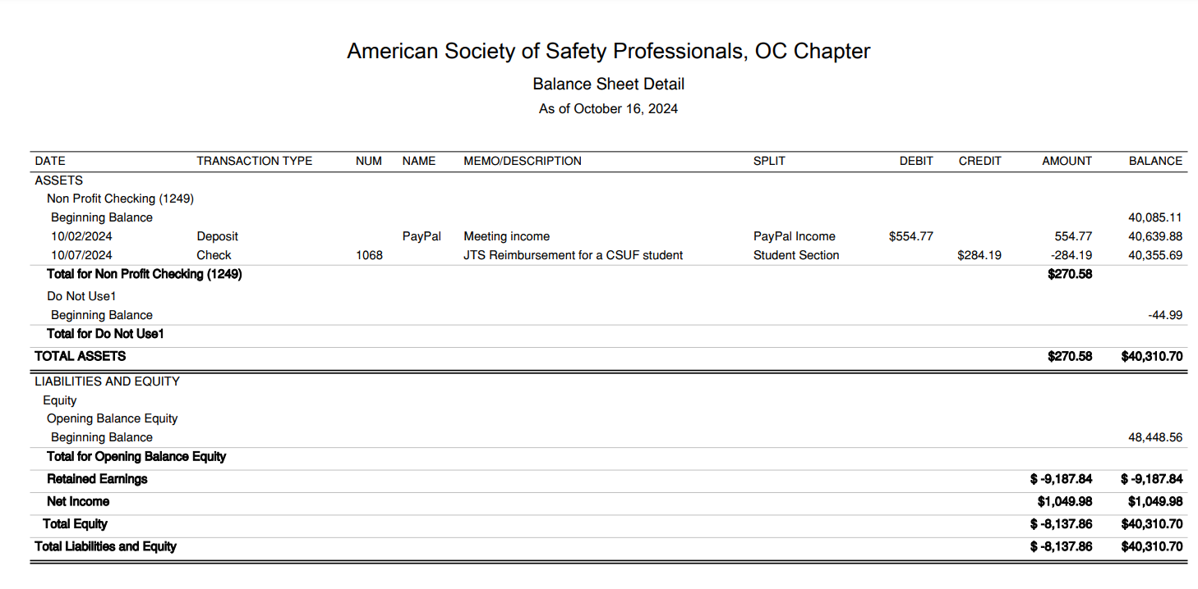

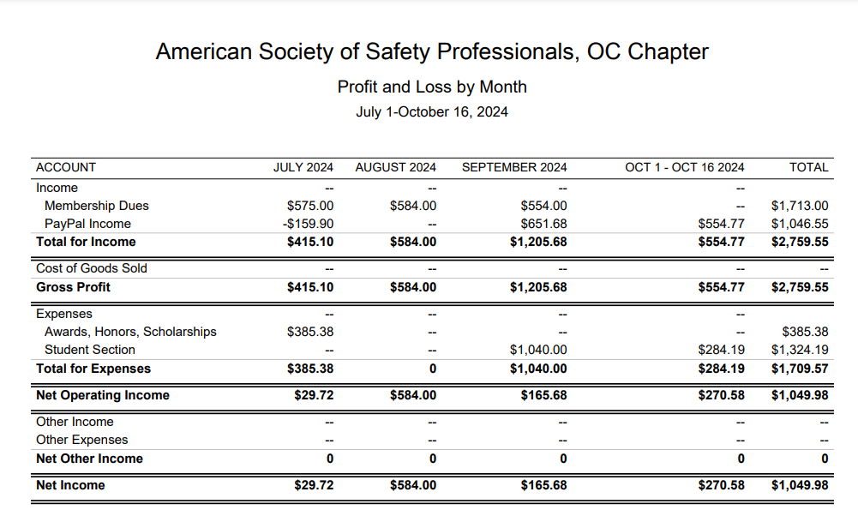

1. **STUDENT SECTION (Danny reporting)**

* The new term is in full swing.
* The November meeting will be led by an alumni.
* Last meeting included a presentation by a CalOSHA inspector.
* Expenses have increased for board members of the student section to attend seminars and other professional development events. Carolyn put a motion to increase the student budget to allow for more members to be able to attend future events. Second by Art. Motion approved.

1. **PROGRAMS (Carolyn reporting)**

* Upcoming
  + 10/26 - Beach cleanup 4PM Huntington Beach
  + 11/14 - Joint event with the LA chapter on November 14th. The presentation will be Heat Illness given by Cal OSHA held at the American Red Cross in Santa Ana
    - Who can help coordinate?
    - Phil to pick up food
    - Tracy to help coordinate
  + **12/17** Holiday Party - Third Tuesday of December held at Lucky Strikes (same as last year)
    - **Action** - Eric to reach out to Carolyn to provide feedback about food
  + January - Plant tour - We have someone offering their wastewater facility in San Bernardino County.
  + January - Fall protection meeting at 3M facility in Tustin
  + March volunteering event with the OC Food Bank - dates TBD

1. **ADVISORY BOARD REPORT (Bob/Teddi/GQ Reporting)**

* Nothing new to report.

1. **GOVERNMENTAL AFFAIRS (Rich Reporting)**

* Nothing new to report. Expect for the remainder of the year to continue to be quiet with more action as we enter 2025.

1. **COMMUNICATIONS / WEB (Danni Reporting)**

* NA

1. **SOCIAL MEDIA (Haley Reporting)**

* 3 new LinkedIn posts scheduled for this week: Thank you JTS post (Monday), Beach Clean Up (Tuesday), and sharing the Mentorship Program (Wednesday).

1. **HONORS & AWARDS REPORT (Phil reporting)**

* Fall scholarship has been announced. 11/1/2024 deadline to follow.
* JTS was a success! Just under 300 total heads including speakers and exhibitors.
* Finances not finalized but expect maybe $20k profit split 5 ways with roughly $4k for each chapter.

1. **MENTORSHIP PROGRAM (Eric/Danny reporting)**

* Still looking for more mentors
  + Anyone on the board is welcome to participate!
* Most of the mentees are undergraduates, but there are a few master students.
* Still working on determining how to expand to the young professionals.

**11. JOBS (Haley Reporting)**

* Three new jobs posted

**12. MEMBERSHIP (Bhavika reporting)**

* Still having issues generating the new member reports. Jess said this was mentioned at the ROC
* **Action** - Jess to send Carolyn the information about creating a login to run membership reports

**_________________________________________________________________**

**ADJOURNMENT**

* **Meeting adjourned** at **12:52** pm

**NEXT MEETING**

* **Third Wednesday of each month**
* **November 20, 2024 (12:00 pm)**
  + Join Zoom Meeting:
    - Meeting ID: 869 4414 9119
    - Passcode: OCASSP
    - Link: https://us06web.zoom.us/j/86944149119?pwd=akdjS1U3MmR6NWZLcEYyUkFROWcwdz09

**_______________________________________________________________________________________________**

**RECAP OF NEW AND CARRY OVER ACTION ITEMS FROM THIS MEETING**

* **Action** – Jess to send Carolyn the information about creating a login to run membership reports
* **Action** – Eric to reach out to Carolyn to provide feedback about food
* **Action** –
* **Action** –
* **Action** –
* **Action** –
* **Action** –
* **Action** –
* **Action** –
* **Action** –
* **Action** –

**____________________________________________________________________________________**