**QUORUM: (President or President-Elect, 3 Committee Members (including 1 elected Executive Committee Member)**

|  |  |  |  |  |  |
| --- | --- | --- | --- | --- | --- |
| Attended | Name | Position | Attended | Name | Position |
| ☒ | Carolyn Oakes | President | ☐ | Rich Warner | Government Affairs |
| ☐ | Jessica Vargas | President-Elect | ☒ | Phillip Combest | Awards & Honors |
| ☐ | Royce Hossler | Secretary | ☒ | Danni Acevedo | Communications |
| ☒ | Art Pedroza | Treasurer | ☒ | Danny Kim | Student Section |
| ☒ | Teddi Penewell | Advisory Board | ☐ | Eric Brown | Mentorship |
| ☒ | Bob Howarth | Advisory Board | ☒ | Bhavika Lodhia | Membership |
| ☐ | Gorgette Quinn | Advisory Board | ☐ | Brian Nguyen | Member at Large |
| ☒ | Haley Binder | Job Chair |  |  |  |
| ☐ | ~~Rollin Gordon~~ | Programs |  |  |  |
|  |  |  |  |  |  |

**QUORUM / CALL TO ORDER**

* A quorum being present, the meeting is called to order at 12:04by President, Carolyn Oakes

**APPROVAL OF PREVIOUS MEETING MINUTES**

* August meeting minutes have not been shared. Continuing to contact current secretary, Royce.

**OLD BUSINESS: (PREVIOUS ACTION ITEMS)**

**_______________________________________________________________________________________________**

**NEW BUSINESS:**

1. **PRESIDENT REPORT (Carolyn reporting)**

* Jessica Vargas will represent us at the Fall ROC in Alaska!
* Did everyone receive their shirt?
* Updates to the ASSP website
* Appointing new Secretary
  + Per our Bylaws: “Should a vacancy occur in any elected office, including Secretary, Treasurer, and Advisory Group Member(s) on the ASSP Advisory Group Delegates to the House of Delegates, except President or President-Elect, the President shall appoint, with the approval of the Executive Committee, an eligible member (see Article V, Section 2) to fill the remaining term of office, giving special consideration to current committee Chairpersons and experienced Chapter leaders who have recently completed their terms of office.”
  + *Article V Section 2: Each elected Chapter officer shall be a Society member for one year prior to taking office; exceptions must be approved by the Regional Vice President. However, only a Professional Member or Member (as set forth in Article III, Section 4 of the Bylaws), who has served as either the Secretary or Treasurer may hold the offices of President, or President-Elect. Exceptions must be approved by majority vote of the Executive Committee
  + **Action** – elect a new secretary in the October meeting

1. **PRESIDENT-ELECT REPORT (Jessica Reporting)**

* Jessica has booked everything for the ROC
* **Action** – reimbursement needed

1. **TREASURER REPORT (Art reporting)**

* Reviewed below content with the board

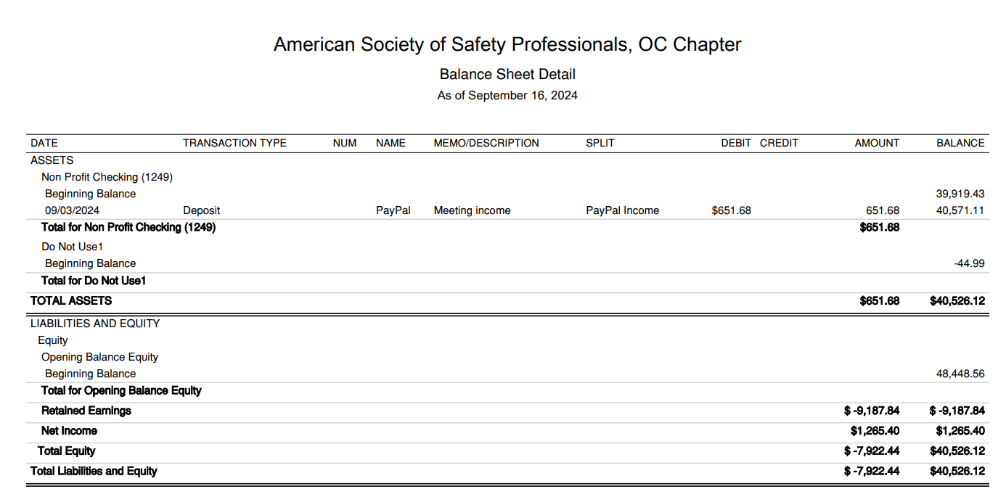

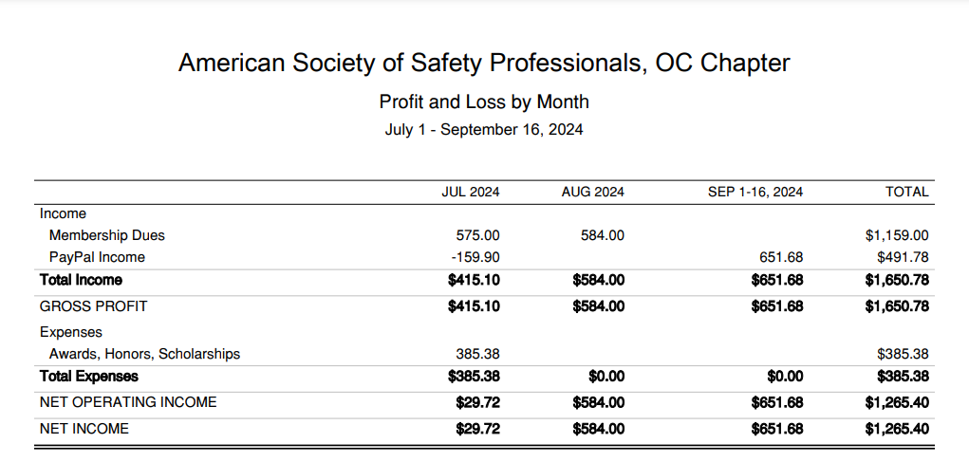

* **Action** – Art to provide information on the negative Paypal amount
* [Approving Budget](https://docs.google.com/spreadsheets/d/1q2T0cto_CX3U1kMhear7jzjXbPD9F9nv/edit?usp=drive_link&ouid=112845075110749799683&rtpof=true&sd=true) - Approved in August meeting

1. **STUDENT SECTION (Danny reporting)**

* Had September meeting
* In October (10/4) will have a speaker from Cal OSHA
* McCarthy is coming to hold a workshop – potentially have opportunities for internships
* Announced the scholarship with the JTS – each organization is sponsoring two students
  + Have at least 4 scholarships available
* Tracy has a contact at Northridge – new contact Jennifer Saba
* Have a new full board
  + **Action** – Danny will reach out to Danni to get the new headshots for student chapter updated on the website

1. **PROGRAMS (Carolyn reporting)**

* Upcoming
  + Sep. 11 -- Joint meeting with OCAIHA. Speaker, food, and optional headshots. Bob Howarth will speak with one of his ABM safety directors about some of the unique challenges in the occupational work space and the client base they have. - success!
    - Need to reimburse the AIHA chapter
    - 10/10 - JTS
    - 10/26 - Beach cleanup 4PM Huntington Beach
      * Who can help coordinate
      * Tracy to help coordinate
      * Haley to help coordinate
    - 11/14 - Joint event with the LA chapter on November 14th. The presentation will be Heat Illness given by Cal OSHA held at the American Red Cross in Santa Ana
      * Who can help coordinate?
      * Phil to pickup food
      * Tracy to help coordinate
      * **Action** – Carolyn to send out the new tracking sheet for future events
    - 12/10 Holiday Party - Second Tuesday of December held at Lucky Strikes (same as last year)
      * Who can help coordinate?
      * Tracy to help coordinate
      * Danni to help coordinate
  + January - Plant tour - We have someone offering their wastewater facility in San Bernardino County.
  + January - Fall protection meeting at 3M facility in Tustin
  + March volunteering event with the OC Food Bank - dates TBD
* JTS
  + Looking good, I think we are past the "break even" point.
  + Got around 200 people so far including speakers and exhibitors.
  + We are nearly sold out of exhibitor space. Maybe 2 tables left.
  + PLEASE COME. We need bodies. It promises to be a great event.
  + Early bird pricing was extended and still good through the end of the week.
  + OCASSP is sponsoring TWO students to come. There is a special room with a program for students. The sponsoring orgs are all sponsoring two students. Some additional students are also sponsored. We are working with Danny to identify the recipients.

1. **ADVISORY BOARD REPORT (Bob/Teddi/GQ Reporting)**

* Bob: Advisory Group met Sept. 12th. The meeting focused on ASSP’s CLEAR values (see overview of values in this 1-minute video <https://youtu.be/1J_aoWhG4oY> ). After introductions, the bulk of the meeting was consumed with to breakout sessions, where we talked about one of the five values. Each breakout room discussed the following questions:

1. How does ASSP exemplify this value?​
2. What are the strengths of ASSP related to this value?​
3. What are the challenges for ASSP related to this value?​
4. What are the areas for improvement for ASSP?

* I participated in the COMMUNITY breakout, where much of the discussion centered on best practices for Chapters with homogeneous memberships can connect with members form a more diverse set of employers.
* **Georgette:** I was in the breakroom for Accountability, we discussed:
  + How does ASSP exemplify this value?
  + What are the strengths of ASSP related to this value?
  + How the Comp report keeps us accountable
    - Maybe points for being involved in the educational opportunities
  + What are the challenges for ASSP related to this value?
    - How we need more checks and balances for the leadership team to be involved in the educational opportunities that ASSP has to offer
  + Leadership conferences
    - Leadership educational resources on the ASSP website
  + What are the areas for improvement for ASSP?
    - Leadership involvement being more consistent in chapter activities

1. **GOVERNMENTAL AFFAIRS (Rich Reporting)**

* "On August 19, 2024, the Director of the Department of Industrial Relations held an Advisory Committee meeting to solicit input regarding proposed changes to California Code of Regulations Title 8 sections 332.4 (Posting of Citation, Special Order, Order to Take Special Action, Notice of No Violations After Investigation), 334 (Classification of Violations and Definition), 335 (Factors Considered in Assessing Civil Penalties), and 336 (Assessment of Civil Penalties). The proposed changes and related information can be viewed at<https://www.dir.ca.gov/dosh/doshreg/Egregious-Violations/>.

The advisory committee invited employers, employer representatives, worker representatives, trade associations, labor organizations, and community groups. The Director is now soliciting additional written input from members of the public, including those who did not participate in the Advisory Committee meeting.

Members of the public may provide written comments at SB606RulemakingComments@dir.ca.gov. **The Director will accept comments submitted via email until 11:59 pm, October 3, 2024.** Please include in your comments the specific edits you are proposing. Once all comments have been reviewed, the Director will post a revised draft of the proposed regulatory text. Thank you for your consideration."

* Just an FYI that the proposed OSHA heat rule was recently released in the Federal Register. The OSHA rule addresses both indoor and outdoor work settings.
  + ASSP will be putting a draft comment together, and we expect it will be long, detailed, and include advocacy of our consensus standards such as A10.50. We expect this will be a big one.
  + The ASSP original/current overall position on heat is:<https://www.assp.org/position-statements>

1. **COMMUNICATIONS / WEB (Danni Reporting)**

* **Action** – Post the video from the meeting on the website – will post on the front facing page immediately then move them to the technical meeting

1. **SOCIAL MEDIA (Haley Reporting)**

* Haley – Social Media – 3 posts since the last meeting

1. **HONORS & AWARDS REPORT (Phil reporting)**

* Fall scholarship will be formally announced in the coming weeks. Deadline to apply is November 1.
* Society will send recognitions (for time spent with the chapter) directly to the members
  + They post this in the newsletter and may also send it to Phil

1. **MENTORSHIP PROGRAM (Eric/Danny reporting)**

* We have updated our flyers and they were sent out to leadership at Orange County and LA Assp and Aihas. We have commitment from UCLA and Northridge for their student population, and we have new representation and commitment from LA ASSP.
* We should hopefully start receiving mentors and students into our database and will hold our zoom orientation meetings in December. I will probably reach out to the JTS to add our flyer to their slideshow.
* The mentorship program will be similar to last year
  + Limited participants from UCLA and Cal St Northridge last year – hoping for more involvement for this year
  + Hope to expand to not only students but also to young professionals – how do we think we can get young professionals to be more involved in mentorship programs?
* **Action** – Carolyn to send out the flyer for mentorship to the board with the meeting minutes
* **Action** – Danni to send out the mentorship flyer to members
* **Action** – Haley to post the mentorship flyer on LinkedIn
* **Action** – Danny to create a flyer focused on young professionals

**11. JOBS (Haley Reporting)**

* Only 2 new posts this month

**12. MEMBERSHIP (Bhavika reporting)**

* **Action** – pull the data for long time members; send out this information at the beginning of the year in January
* Sent out 15 emails to expired members (two bounced back)

**_________________________________________________________________**

**ADJOURNMENT**

* **Meeting adjourned** at **12:52** pm

**NEXT MEETING**

* **Third Wednesday of each month**
* **October 16-, 2024 (12:00 pm)**
  + Join Zoom Meeting:
    - Meeting ID: 869 4414 9119
    - Passcode: OCASSP
    - Link: https://us06web.zoom.us/j/86944149119?pwd=akdjS1U3MmR6NWZLcEYyUkFROWcwdz09

**_______________________________________________________________________________________________**

**RECAP OF NEW AND CARRY OVER ACTION ITEMS FROM THIS MEETING**

* **Action** – elect a new secretary in the October meeting
* **Action** – reimbursement needed for Jessica for the ROC
* **Action** – Art to provide information on the negative Paypal amount
* **Action** – Danny will reach out to Danni to get the new headshots for student chapter updated on the website
* **Action** – Carolyn to send out the new tracking sheet for future events
* **Action** – Post the video from the meeting on the website – will post on the front facing page immediately then move them to the technical meeting
* **Action** – Carolyn to send out the flyer for mentorship to the board with the meeting minutes
* **Action** – Danni to send out the mentorship flyer to members
* **Action** – Haley to post the mentorship flyer on LinkedIn
* **Action** – Danny to create a flyer focused on young professionals
* **Action** – pull the data for long time members; send out this information at the beginning of the year in January

**____________________________________________________________________________________**