**QUORUM: (President or President-Elect, 3 Committee Members (including 1 elected Executive Committee Member)**

|  |  |  |  |  |  |
| --- | --- | --- | --- | --- | --- |
| Attended | Name | Position | Attended | Name | Position |
| ☒ | Brian Nguyen | President | ☐ | Rich Warner | Government Affairs |
| ☒ | Carolyn Oakes | President-Elect | ☒ | Phillip Combest | Awards & Honors |
| ☐ | Jessica Vargas | Secretary | ☐ | Danni Acevedo | Communications |
| ☒ | Art Pedroza | Treasurer | ☐ | Danny Kim | Student Section |
| ☒ | Teddi Penewell | Advisory Board | ☐ | Eric Brown | Mentorship |
| ☒ | Azza Carmona | Advisory Board | ☐ | Bhavika Lodhia | Membership |
| ☐ | Georgette Quinn | Advisory Board | ☐ | Bob Howarth | Programs |
| ☐ | Royce Hossler | Job Chair | ☐ | Claudia Morgado | Member-at-Large |
|  | Rollin Gordon |  |  |  |  |
|  |  |  |  |  |  |

**QUORUM / CALL TO ORDER**

* A quorum being present, the meeting is called to order at 12:05by President, Brian Nguyen

**APPROVAL OF PREVIOUS MEETING MINUTES**

* April meeting minutes approved.

**OLD BUSINESS: (PREVIOUS ACTION ITEMS)**

* **April 23’** Brian to work with Art to put together year end financials to submit by May 31, 2024.
* **April 23’** Brian to forward invitation email to year-end student meeting at CSUF.
* **April 23’** Brian to reschedule the next meeting from May 15th to May 14. DONE

**_______________________________________________________________________________________________**

**NEW BUSINESS:**

1. **PRESIDENT REPORT (Brian reporting)**

* Tomorrow (5/15) is the joint ASSP / OCRIMS meeting
  + 35 registered
  + Following the event is a tour at the Honda Center
* Carolyn and Brian met to begin to review the transition meeting and COMPT
  + Need the financial document from Art
  + Will be a Platinum Chapter
  + Transition dinner on June 29th at the Macaroni Grill at 6-9PM
* Cancelling the June Board Meeting (June 19th)

1. **PRESIDENT-ELECT REPORT (Carolyn Reporting)**
   * Include the new board in the save the date for the transition meeting
   * Will be connecting with Brian to finalize the budget for next year
2. **TREASURER REPORT (Art reporting)**

\***PLACEHOLDER**\*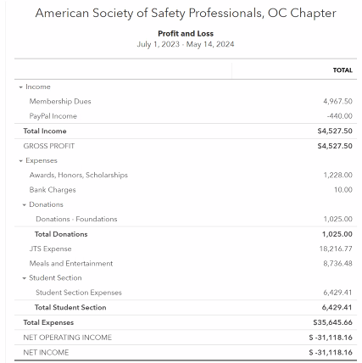

1. **STUDENT SECTION (Danny reporting)**

* Recent award to a safety professional who started in the student chapter – great way to highlight ASSP to students
  + Azza will be connecting Danny and him via email
* 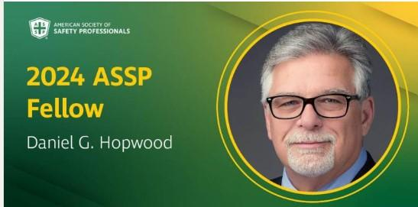
* Eric Brown -mentoring program is going well, gonna call for ending this month and ask for feedback. We had 3 students that flaked on their mentors, so we will be more aggressive about that next yeat

1. **PROGRAMS (Bob reporting)**

* Two events left
  + Meeting on 5/15 technical meeting with a speaker talking about AI
  + Transition meeting on 6/29th at Macaroni Grill (off Jamboree) from 6-9PM

1. **ADVISORY BOARD REPORT (Azza/Teddi/GQ Reporting)**

* Board was recently asked about AI
* Next meeting on 5/23

1. **GOVERNMENTAL AFFAIRS (Rich Reporting)**

* NA

1. **COMMUNICATIONS / WEB / SOCIAL MEDIA (Danni Reporting)**

* Brian – continuing our presence in LinkedIn
  + Posting jobs, updates from recent events
* 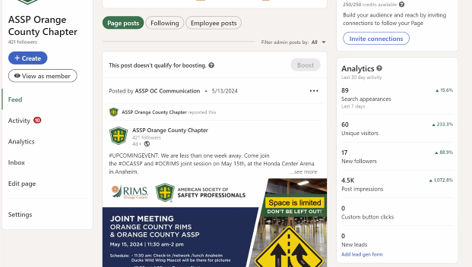

1. **HONORS & AWARDS REPORT (Phil reporting)**

* Carolyn to get with Brian to determine the amount of awards we have to include in our budget
  + Phil will be sending the budget to Carolyn, Brian and Art

1. **MENTORSHIP PROGRAM (Eric/Danny reporting)**

* Eric - Mentoring program is going well, gonna call for ending this month and ask for feedback. We had 3 students that flaked on their mentors, so we will be more aggressive about that next year
* Danny submitted the draft budget for the student chapter for next year

**11. JOBS (Royce Reporting)**

* Posted new jobs on the website and LinkedIn

**12. MEMBERSHIP (Bhavika reporting)**

* Sent numerous communications to new members on 5/13 – 58 emails

**_________________________________________________________________**

**ADJOURNMENT**

* **Meeting adjourned** at **12:42** pm

**NEXT MEETING**

* **Third Wednesday of each month**
* **June 19, 2024 (12:00 pm) - CANCELLED**
  + Join Zoom Meeting:
    - Meeting ID: 869 4414 9119
    - Passcode: OCASSP
    - Link: https://us06web.zoom.us/j/86944149119?pwd=akdjS1U3MmR6NWZLcEYyUkFROWcwdz09

**_______________________________________________________________________________________________**

**RECAP OF NEW AND CARRY OVER ACTION ITEMS FROM THIS MEETING**

* **May 23’** Carolyn to get with Brian to determine the amount of awards we have to include in our budget
* **May 23’** Phil will be sending the budget to Carolyn, Brian and Art
* **May 23’** Azza will be connecting Danny and him via email
* **May 23’** Will be connecting with Brian to finalize the budget for next year

**____________________________________________________________________________________**