QUORUM: (President or President-Elect, 3 Committee Members (including 1 elected Executive Committee Member)
Attended | Name | Position | Attended | Name | Position
☒ | Brian Nguyen | President | ☐ | Rich Warner | Government Affairs
☒ | Carolyn Oakes | President-Elect | ☒ | Phillip Combest | Awards & Honors
☐ | Jessica Vargas | Secretary | ☐ | Danni Acevedo | Communications
☒ | Art Pedroza | Treasurer | ☐ | Danny Kim | Student Section
☒ | Teddi Penewell | Advisory Board | ☐ | Eric Brown | Mentorship
☒ | Azza Carmona | Advisory Board | ☐ | Bhavika Lodhia | Membership
☐ | Georgette Quinn | Advisory Board | ☐ | Bob Howarth | Programs
☐ | Royce Hossler | Job Chair | ☐ | Claudia Morgado | Member-at-Large
 | Rollin Gordon

QUORUM / CALL TO ORDER
- A quorum being present, the meeting is called to order at 12:05 by President, Brian Nguyen

APPROVAL OF PREVIOUS MEETING MINUTES
- April meeting minutes approved.

OLD BUSINESS: (PREVIOUS ACTION ITEMS)
- April 23’ Brian to work with Art to put together year end financials to submit by May 31, 2024.
- April 23’ Brian to forward invitation email to year-end student meeting at CSUF.
- April 23’ Brian to reschedule the next meeting from May 15th to May 14. DONE
_______________________________________________________________________________________________

NEW BUSINESS:
- PRESIDENT REPORT (Brian reporting)
- Tomorrow (5/15) is the joint ASSP / OCRIMS meeting
  - 35 registered
  - Following the event is a tour at the Honda Center
- Carolyn and Brian met to begin to review the transition meeting and COMPT
  - Need the financial document from Art
  - Will be a Platinum Chapter
  - Transition dinner on June 29th at the Macaroni Grill at 6-9PM
- Cancelling the June Board Meeting (June 19th)

- PRESIDENT-ELECT REPORT (Carolyn Reporting)
  - Include the new board in the save the date for the transition meeting
  - Will be connecting with Brian to finalize the budget for next year

- TREASURER REPORT (Art reporting)
*PLACEHOLDER*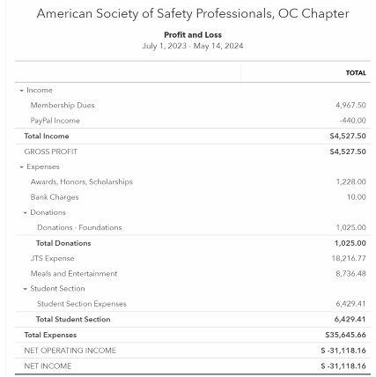
- STUDENT SECTION (Danny reporting)
- Recent award to a safety professional who started in the student chapter – great way to highlight ASSP to students
  - Azza will be connecting Danny and him via email
- 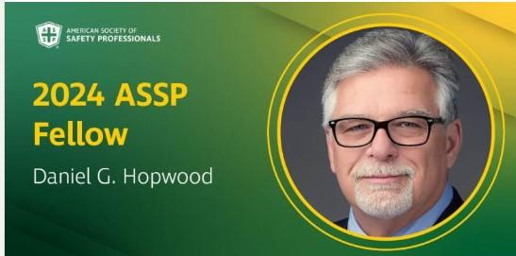

- Eric Brown -mentoring program is going well, gonna call for ending this month and ask for feedback. We had 3 students that flaked on their mentors, so we will be more aggressive about that next yeat

- PROGRAMS (Bob reporting)
- Two events left
  - Meeting on 5/15 technical meeting with a speaker talking about AI
  - Transition meeting on 6/29th at Macaroni Grill (off Jamboree) from 6-9PM

- ADVISORY BOARD REPORT (Azza/Teddi/GQ Reporting)
- Board was recently asked about AI
- Next meeting on 5/23

- GOVERNMENTAL AFFAIRS (Rich Reporting)
- NA

- COMMUNICATIONS / WEB / SOCIAL MEDIA (Danni Reporting)
- Brian – continuing our presence in LinkedIn
  - Posting jobs, updates from recent events
- 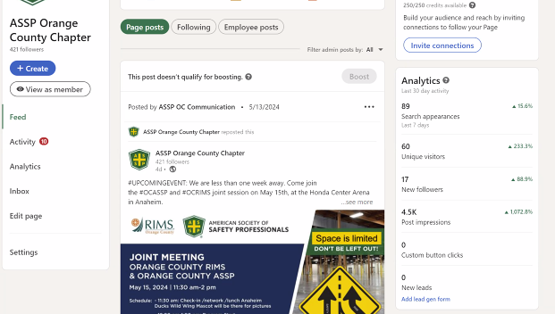

- HONORS & AWARDS REPORT (Phil reporting)
- Carolyn to get with Brian to determine the amount of awards we have to include in our budget
  - Phil will be sending the budget to Carolyn, Brian and Art

- MENTORSHIP PROGRAM (Eric/Danny reporting)
- Eric - Mentoring program is going well, gonna call for ending this month and ask for feedback. We had 3 students that flaked on their mentors, so we will be more aggressive about that next year
- Danny submitted the draft budget for the student chapter for next year

11. JOBS (Royce Reporting)
- Posted new jobs on the website and LinkedIn

12. MEMBERSHIP (Bhavika reporting)
- Sent numerous communications to new members on 5/13 – 58 emails
_________________________________________________________________
ADJOURNMENT
- Meeting adjourned at 12:42 pm

NEXT MEETING
- Third Wednesday of each month
- June 19, 2024 (12:00 pm) - CANCELLED
  - Join Zoom Meeting:
    - Meeting ID: 869 4414 9119
    - Passcode: OCASSP
    - Link: https://us06web.zoom.us/j/86944149119?pwd=akdjS1U3MmR6NWZLcEYyUkFROWcwdz09
_______________________________________________________________________________________________
RECAP OF NEW AND CARRY OVER ACTION ITEMS FROM THIS MEETING
- May 23’ Carolyn to get with Brian to determine the amount of awards we have to include in our budget
- May 23’ Phil will be sending the budget to Carolyn, Brian and Art
- May 23’ Azza will be connecting Danny and him via email
- May 23’ Will be connecting with Brian to finalize the budget for next year

____________________________________________________________________________________

